SAMARA V2.1

MODEL DESCRIPTION AND

GUIDELINES FOR CALIBRATION

June 2013

Based on developments funded in part by GTZ/BMZ and CCAFS

**Contacts for questions & comments:**

Michael Dingkuhn, [m.dingkuhn@irri.org](mailto:m.dingkuhn@irri.org), [dingkuhn@cirad.fr](mailto:dingkuhn@cirad.fr)

Richard Pasco, [r.pasco@irri.org](mailto:r.pasco@irri.org)

Jean-Christophe Soulie, [jean-christophe.soulie@cirad.fr](mailto:jean-christophe.soulie@cirad.fr)

SAMARA V2.1

Description of model

Michael Dingkuhn, IRRI 30/06/2013, [dingkuhn@cirad.fr](mailto:dingkuhn@cirad.fr), m.dingkuhn@irri.org

1. **General description**

SAMARA V2 is a deterministic cereal (except maize) crop model operating at daily time step. The current V2 version replaces the V1 of 2010-2011 which did not simulate flooded crops and corresponding water management, and it has numerous other improvements, so some of the parameter values will not be the same for a given genotype. A future version V3 will simulate photosynthesis in more detail (including CO2 response) and incorporate the phenology of RIDEV, a rice model considering organ temperature and microclimate. V3 will not replace V2 but rather, will serve as a specialized version for climate-change related studies.

SAMARA requires daily agro-meteorological weather data as input (Rg or hours of sunshine, Tmin, Tmax, RHmin, RHmax, daily mean wind speed, daily total rainfall), as well as hydrological top soil properties (volumetric water content of air-dry soil, at wilting point, at field capacity and at saturation = water logging; and percolation rate under flooded condition and soil depth as limit to the root front). SAMARA does not consider soil bulk density and swelling/shrinkage.

SAMARA is implemented as a modular system on the ECOTROP platform that also accommodates SARRAH Heinemann et al., 2008; Kouressy et al., 2008) and EcoPalm (Combres et al., 2012), programmed in Delphi language, and implemented under Windows.

SAMARA is different from other agronomy-scale (plot) crop models in the way it treats assimilate partitioning among sinks, also involving more detail of morphology and phenology. Plant and organ growth is not only limited by carbon assimilation (source or supply) but also demand, which is the accrued organ sink capacity for growth and respiration on a given day. Since organ potential size and number (leaf appearance and tillering rates, panicle size) may be genetically limited, or more or less responsive to resources and stresses, demand can be inferior to supply. The state variable Ic (Index of internal competition = supply / demand) measures the source-sink situation daily and feeds back on morphogenetic and physiological processes, such as reserve storage of mobilization, tiller initiation or senescence, leaf size, leaf senescence, internode elongation, root growth and pre-floral panicle dimensioning. Carbon demand for root growth depends on the available soil volume, among other things (e.g., set by soil depth and plant spacing). It can happen that assimilates cannot be used entirely for lack of sinks and storage, resulting in feedback inhibition of photosynthesis, effectively reducing RUE. It can also happen that sink development is excessive (e.g., profuse tillering), causing much senescence and also reduced RUE. Such crowding effects cannot be well simulated with crop models having fixed partitioning and senescence patterns.

This concept, adapted from the EcoMeristem model (Luquet et al., 2006, 2007, 2012), thus deviates from the classical “prescriptive” partitioning concept that assumes constant RUE in the absence of physiological stresses. SAMARA therefore permits simulating **phenotypic plasticity** that may be adaptive or not, and simulating different adaptation strategies such as aggressive or more conservative use of resources. According to SAMARA, the growth and yield potential of a genotype is not only a function of potential photosynthetic rate and light interception (source), but of the dynamics and resource responsiveness of the morphogenetic process itself (demand). The model thereby considers water resources and drought / logging / submergence / thermal stresses, but not mineral nutrition.

SAMARA deviates from EcoMeristem in its agronomic skills, while being less detailed in plant architecture. SAMARA provides for many crop management options including transplanting vs. direct seeding, or flexible and diverse water management options (stress cycles, alternate wetting and drying, deficit irrigation), and mulching. The modified big-leaf simulation of light interception in SAMARA also implements a simple notion of clumping (heterogenous leaf area distribution in space). Lastly, it is possible to output ecological balances such as canopy scale transpiration efficiency, plot-level water use efficiency and irrigation efficiency, and radiation use efficiency.

A commented listing of the model code is provided separately. Only the functional principles are described here. Note that the precursor model SARRAH (on which SAMARA partially builds) and the ECOTROP software were originally written in French, and the later developments such as SAMARA in English. We tried to translate the essentials into English but the variables and parameters inherited from SARRAH remain in French. Commented lists of input/output variables and parameters are provided separately.

1. **Purpose of SAMARA**

SAMARA was developed to study in-silico plant type (ideotype) concepts submitted to different climatic/soil environments and management practices. As such it permits evaluating the adaptive and agronomic value of many of the traits breeders are interested in, alone and in combination. The strength of SAMARA is the simulation of physiological interactions among traits and with the environment and management. SAMARA is thus a tool for pre-breeding research, including target population of environments (TPE) characterization and *in-silico* ideotype development.

For purposes such as agronomic decision support or mapping of climatic yield potential, SAMARA is over-parameterized with regards to genotype characteristics. Although an effort was made to separate frequently used parameters of rarely used ones, the number of parameters is very large and calibration of some is difficult because their values are not directly measurable. (A parameter optimization tool for the most difficult ones is under development.)

SAMARA can be a valuable didactic tool for crop physiologists and agronomists. “Playing” with parameter values teaches users how adjustment processes in the plant (e.g., tillering vs. leaf size), trade-offs among traits (e.g., plant height vs. harvest index) and trade-offs among cultural practices (e.g., plant spacing vs. varietal type) come about and affect the agronomic outcome.

1. **Specific features of SAMARA V2: How they work, How to use them**
   1. ***The user interface***

SAMARA has an extensive user interface under Windows with many screens and menus, including graphics that instantly show simulation results and allow graphic comparisons with observed data. All model parameters can be modified freely by the user, which is an advantage to the skilled model user (e.g., for the creation of hypothetical genotypes) but also involves the risk of false, biologically meaningless results. Consequently, despite the user-friendliness of the interface, the model is meant for expert hands only and requires thorough crop physiological understanding and familiarity with the model’s algorithms.

Any simulation scenario defined by the user is stored and readily accessible thereafter, unless actively deleted. A simulation scenario is a combination of choice of a user-defined plot (1) (including the soil), (2) location (including the climate), (3) cultural practices (including sowing data and irrigation management) and (4) crop (including all genotype characteristics). New simulations can be easily generated by changing only the plot, location, cultural practices or crop (variety) sub-scenarios. Many such pre-defined scenarios can be implemented at the same time for an unlimited number of years (depending on available data), and can be graphically output together (super-imposed with different colors and symbols). Output of numerical results are possible as complete set (all variables for all days for all scenarios) or as a condensed set (key variables) in a text file. All external input data is imported from text files as well (but should be prepared under Excel).

A step by step instruction manual is provided separately.

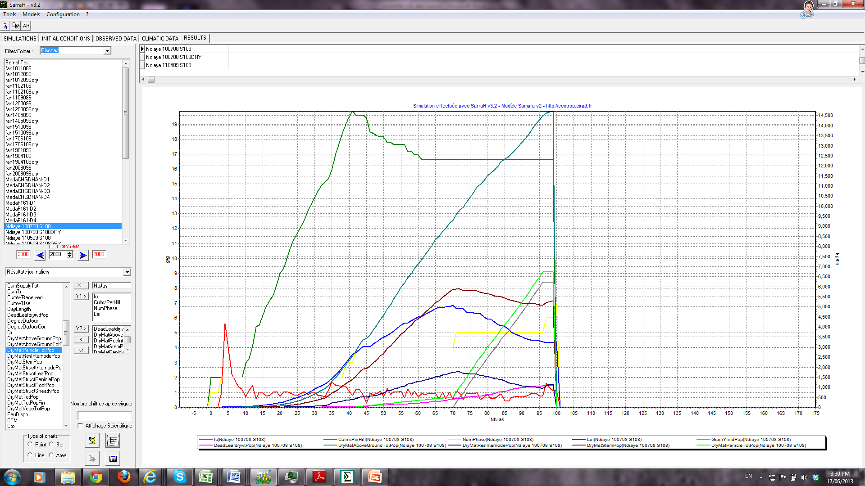

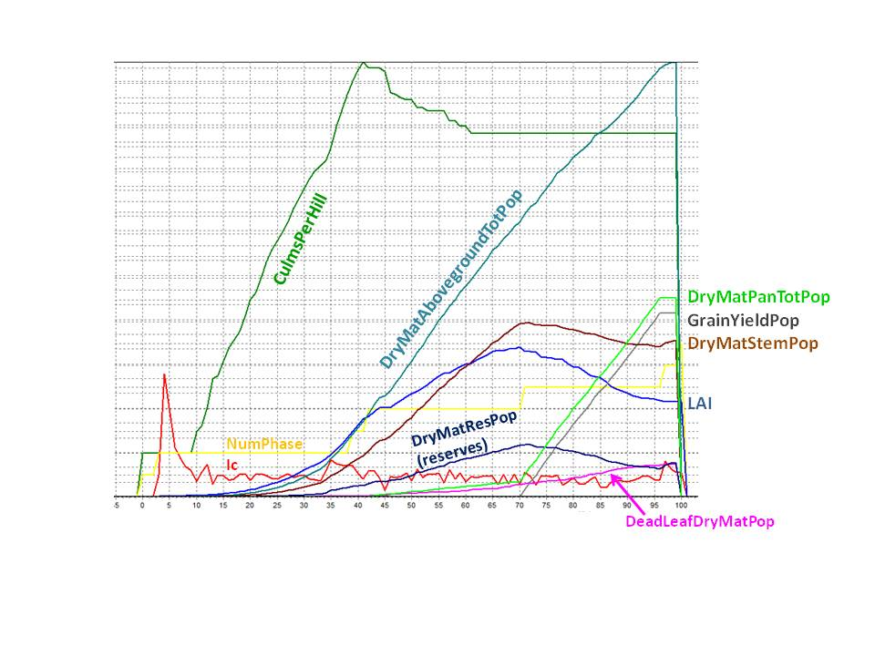

***3.2 Baseline plant functioning under potential conditions***

*3.2.1 Phenology*

The phenology of SAMARA has 2 components, (1) the development phases that essentially represent thermal time intervals leading up to planicle initiation, flowering and then maturity; and (2) the temporal organization of organ development including leaves (phyllochron), internodes and tillers.

*3.2.1.1. Development phases*

Six development phases (NumPhase1, 2, 3…) are successively implemented, namely germination (SdjLevee), basic vegetative phase BVP (SdjBvp), photoperiod-sensitive phase PSP, reproductive phase (SdjRPR), maturation phase #1 during which grains are filled (SdjMatu1) and maturation phase #2 (SdjMatu2) at the end of which the grains have attained physiological maturity and the simulation ends. (Note that sdj stands for degree-days.) The length of these phases is set by the SdjBVP, SdjXxx… parameters, except for PSP.

Thermal duration is simulated by the model with genotypic, cardinal temperatures Tbase, Topt1, Topt2 and Tlim (=Tmax). No phenological development happens below Tbase and above Tlim, and development rate is maximal and constant between Topt1 and Topt2. Variation of ambient T during the day and night is included in the calculation of thermal time but this still needs improvement. Also, SAMARA V2 only considers air temperature at 2m and not organ temperature. The V3 version will introduce the RIDEV model algorithms that simulate hourly organ (meristem) temperature patterns.

The PSP has no fixed thermal duration as it depends on day length. The Impatience model of photoperiodism is implemented (Dingkuhn et al., 2008). It is a day-length threshold type of model with the specificity that the threshold is not fixed. The longer the plant has to wait (in terms of thermal time) for the right day length to occur, the more it relaxes the threshold requirement. This is a concept borrowed from animal ethology (threshold lowering under prolonged appetence) and proved to explain photoperiodism in sorghum better than other models. Although the model uses 4 parameters, only one of them (PPsens) is usually needed to fit a genotype.

*3.2.1.2. Timing of organogenetic processes*

An important feature in SAMARA is the simulation of **leaf appearance rates** (=1/phyllochron [oC.d]). Genotypes having a long phyllochron build up leaf area more slowly (frequently associated with larger leaves and lower tillering rate). The base phyllochron between the 4th leaf and the leaf appearing at PI is implemented with the parameter Phyllo [oC.d]. Leaves 1-3 appear faster because they are pre-formed in the embryo already on the mother plant. Leaves produced after PI (which is during stem elongation phase) appear more slowly in grasses (secondary phyllochron). The ratio of primary over secondary phyllochron (typically around 0.5) is implemented with the parameter RelPhylloPhase StemElong. In cases where >20 leaves are produced before PI, stem elongation sets on earlier and with it, the secondary phyllochron. This is unlikely to happen in rice but occurs in sorghum, which produces leaves at a much faster rate than rice.

The organogenetic developmental stage of the crop (number of phytomers syn. Number of leaves on the main culm) is calculated as the state variable **HaunIndex**, referring to the system proposed by Haun.

Potential leaf size is controlled by leaf position or HaunIndex, assuming leaf blade length to increase linearly from L1 to the rank of the longest leaf (RankLongestLeaf, equal to about 10 in rice), and assumed to be constant thereafter. (Note that depending on resources, actual simulated leaf length may be smaller than potential. This can be output with variables LastLeafLengthPot and LasLeafLength)

Stem (internode) elongation is restricted to the period described above and stops at flowering. Internodes are not simulated individually. Their potential mean length (InternodeLengthMax) and specific dry weight (CoeffInternodeMass = dw per mm length) is set by crop parameters. The number of elongating internodes per culm is equal to the number of phyllochrons elapsing between PI and flowering, multiplied by CoeffInternodeNum (crop parameter usually set to 1.5).

Tillering is authorized only between HaunCritTillering (the leaf rank at which tillering potentially sets on, e.g., 3) PI (= PBP+PSP). Tiller senescence is authorized between end of BVP and mid-reproductive stage (ca. 10d before flowering. **Tillering and tiller abortion are driven by resources through Ic**, attenuated by crop parameters (TilAbility and CoeffTillerDeath). Tillering is also attenuated by light transmission of the canopy as a proxy for light quality effects. (The NR/FR ratio is smaller under a dense canopy.)

The structural part of the panicle (DryMatPanStructPop) develops from PI onwards as a fraction of overall growth rate (CoeffStructPanMass), capped by a genotypic maximum (PanStructMassMax). The panicle structure stops growing at flowering. From flowering onwards, no structural growth (organogenesis) happens any more anywhere on the plant, the only sinks being grain filling, maintenance and root growth (if authorized by the user, and if unexplored soil volume is still available for root growth). Excess assimilates, if any, go into reserve storage in the stem (internodes + sheaths).

*3.2.2 Morphology and light interception*

Although SAMARA simulates light interception on the basis of the big-leaf concept, the model considers some morphological detail of the canopy such as culm and leaf number, apex height (= culm length) and plant height, and plant crown width. Individual leaf size per rank is also simulated. Both leaf area production and death are simulated in a cumulative way. It is thereby assumed that new leaves are generated at the top of the canopy and leaf death occurs at the bottom of the canopy. **Leaf death is driven by Ic** (supply over demand) and happens when Ic<1. The response rate of leaf death to Ic is set by the parameter CoeffLeafDeath. Dying leaves are partially recycled into the daily assimilate budget.

Specific leaf area (on a structural basis, not including reserves) is simulated on the basis of 3 crop parameters (SLAmax, SLAmin and AttenMitch, of which the latter (a slope variable for a Mitscherlich function) should not be modified normally). The crop initially starts with the SLAmax value and matures with the SLAmin value, meaning that the leaves get thicker. **The algorithm calculating SLA is implemented daily for the new leaf area produced, it thus does not force old leaves to get thicker than they were when they were produced**. This is important because the average SLA of a crop at a given stage is constituted by leaves at different times and thus have different SLA. A particular algorithm provides for SLA to be lower under cold conditions (thicker leaves), which can be calibrated with the parameter TempSla (0…1).

In SAMARA V2.1, CO2 assimilation rates can be sensitized to the dynamics of SLA, high SLA thereby reducing the rates (parameter CoeffAssimSla).

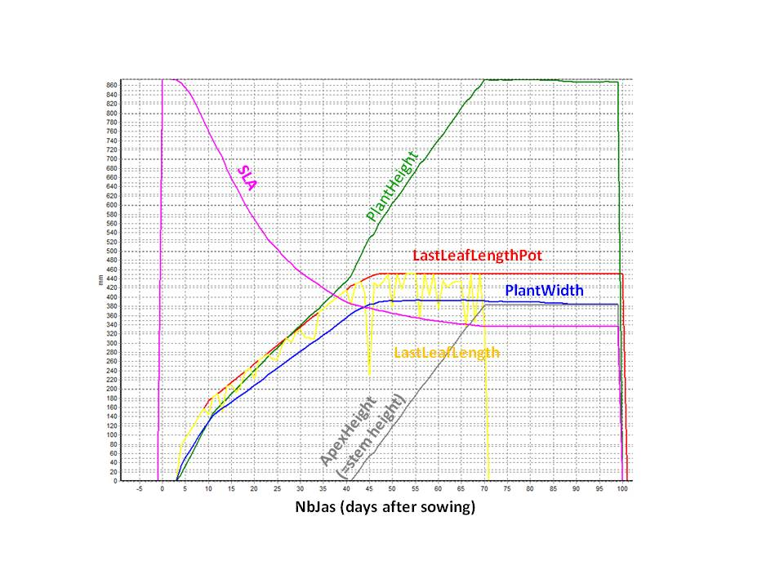

Most crop models using SLA as a determinant for conversion of leaf dw into leaf area are excessively sensitive to the SLA parameter. This is not so much the case in SAMARA because of the many physiological feedbacks in the model on morphology and partitioning, and also because of the more biological way SAMARA is simulating SLA.

**Light interception** of the canopy is simulated with Beer-Lambert’s law on the basis of leaf blade aggregate LAI. This law was modified to include the effect of clumping, based on soil surface area that does not carry a canopy, in turn calculated from plant width, height and mean population spacing. Sheath and panicle light interception are not simulated. Light interception is sensitive to submergence and drought-induced leaf rolling.

Depending on floodwater depth in aquatic culture, a portion of the leaf area is not considered to be photosynthetically active. **Partial submergence** reduces CO2 assimilation in a sub-proportional way because most leaf area is located at the top and not at the bottom where the water is. In the case of **total submergence**, carbon assimilation is considered as zero and causes plant death after a few days, when maintenance has consumed the stored carbon reserves.

**Water logging** (filling-up of air spaces in the soil with water) is simulated and results from greater water supply (rain + irrigation) than consumption (transpiration + evaporation) plus percolation. It acts as a stress if crop parameter WaterLoggingSens > 0, thereby reducing transpiration and assimilation through the state variable Cstr.

*3.2.3. Supply and demand: Ic as a proxy for sugar signaling*

Ic is a state variable, the ratio of aggregate, fresh assimilate supply over aggregate demand at the whole plant level, minus maintenance. Supply does not include carbon reserves (in stems: leaf sheaths and internodes) nor recycled material from organ senescence, which only kick in when Ic < 1. Demand includes the following:

* The incremental, potential growth of **expanding leaves and sheaths** on all **tillers** (based on their potential size that depends on leaf rank and the fraction of that growth to be realized during the day, assuming that full expansion happens within one phyllochron);
* The incremental, potential growth of all **elongating internodes**, on the same basis;
* The incremental, potential, aggregate assimilate needed for **grain filling**, based on the day’s thermal-time fraction of SdjMatu1. (Grain filling is assumed to be linear during the entire Matu1 phase);
* The demand of the **root system** for growth, based on the day’s progression of the root front (and a proportional lateral progression but limited by the soil surface attributed to the plant in a canopy context), the current root dw per soil volume, and the potential root dw per soil volume as set by a parameter. Partitioning to roots is capped by a crop parameter called RootPartitMax (set to 1.0 normally, indicating that root partitioning cannot be greater than shoot partitioning).
* The user can declare the stem **reserve storage compartment as being an active sink**, by setting CoeffReserveSink > 0. The unfilled part of the sink compartment then contributes to overall demand. Otherwise, the storage compartment acts only as a **spill-over pool** (passive sink).

Ic is a proxy for hypothetical **sugar signaling** affecting organ initiation in meristems or tiller buds, organ down-sizing under limited resources, and triggering of tiller outgrowth and leaf and tiller senescence. Tillering is authorized at Ic > 0.5 because tiller outgrowth can be observed even under mild assimilate shortage and thus is proportional to (Ic-0.5) and to the parameter TilAbility. The critical Ic for tillering can be modified if needed (parameter IcTillering).

Potentially, Ic can feed back on many other processes such as development rate (slower progress to flowering under shortage of assimilates), leaf appearance rate, photosynthesis, respiration, growth of specific organs, etc. These functions are not available at present but can be easily implemented upon demand. Cstr (stress) can already optionally feed back on development rate through “stretching” of thermal time.

Ic driven feedbacks are a powerful mechanism for plant growth and development adjustments to the resource situation, but they make the model difficult to parameterize: Through Ic, all development and growth processes interact, and when one parameter is adjusted, many others need to be adjusted too.

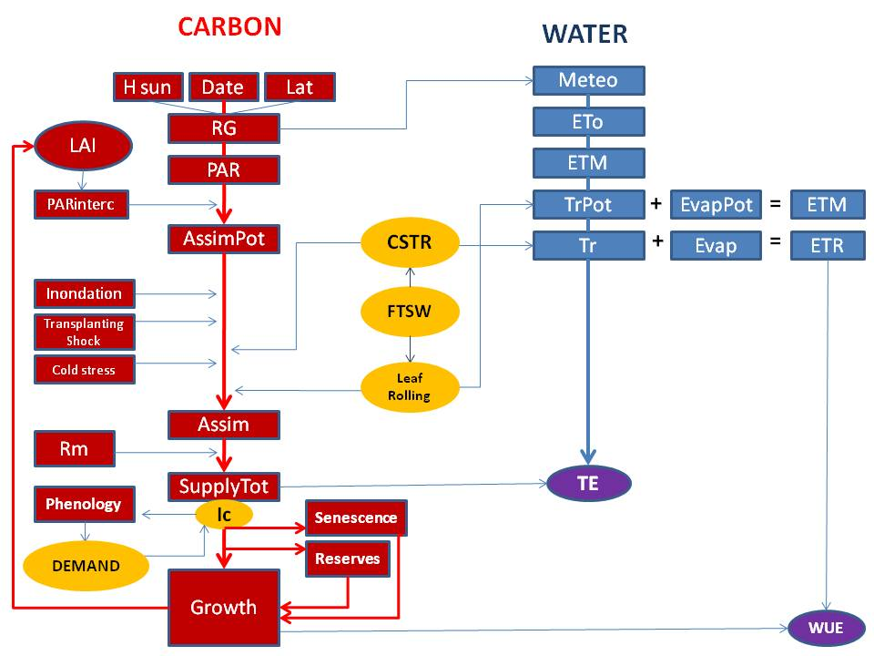

*3.2.4. Assimilation and maintenance*

Carbon assimilation in SAMARA V2 is based on a modified concept of radiation use efficiency (RUE; ad dry biomass / intercepted PAR), whereby the aboveground dry biomass term is substituted with net canopy photosynthesis. The conversion efficiency in SAMARA V2 is thus the RUE *BEFORE* subtraction of maintenance and partitioning to root growth, and *BEFORE* any consideration of biomass loss through senescence.

The effective, simulated **RUE** based on the textbook definition can be output by the model. Roughly, the simulated, effective (textbook) RUE is about half the value of the parameter Conversion (SAMARA’s RUE), the difference being attributable to maintenance, root growth, senescence and unused assimilates if demand is extremely low (e.g., if spikelets are sterile, resulting in feedback inhibition of photosynthesis). Typical RUE for C3 grasses is 1.5-2.2 g dw / MJ, and the corresponding Conversion term in SAMARA V2 is about 4.0 g sugar / MJ. The simulated conversion ratio of PARi to dry biomass can be output with the state variable ConversionEff. It includes effects of SLA dynamics, light level and stresses. The effect of SLA dynamics on Assim can be tuned with the crop parameter CoeffAssimSla.

As we observed that the assumption of a linear relationship between growth and light interception (sic, RUE) under-estimates growth during periods of low PAR, we implemented an empirical, slightly curvi-linear shape for the assimilate vs. PAR relationship. This function cannot be modified by the user. It results in slightly increased RUE under low light conditions.

In SAMARA V2.1, Assim and Tr were sensitized to **ambient CO2 concentration** (Ca) using a simple, non-coupled model inspired by APSIM model. For Assim, a Ca dependent coefficient (CoeffCO2Assim) is calculated using an exponential CO2 response function (Mitscherlich simplified). This function is always 0 (Zero) at the CO2 compensation point CO2Cp (parameter in ppm, val=10 for C4 and val=50 for C3) and is always 1 (one) at Ca=400ppm (current ambient). The curvature of the response is set by CO2Exp, which is about 0.004 for C3 and 0.008 for C4. A similar (but linear) function is used to describe the response of Tr to Ca. It passes through 1 (no effect) at Ca=400ppm and has a negative slope (e.g., CO2Tr = -0.0004) or none (CO2Tr = 0). A more mechanistic model of gas exchange will be developed for SAMARA V3.



Maintenance is calculated on a dw basis using the Q10 law for temperature response. The Q10=2 assumption as implemented in most crop models, however, is only true for non-acclimatized plants and recent literature indicates that the true value is much lower. We thus recommend Q10=1.5 or similar, to be parameterized with CoefficientQ10.

Maintenance at population scale is in reality not a function of plant dw but of its physiological activity, which in turn is closely related to nitrogen content. This was demonstrated for rice by Ingram et al. (1990). SAMARA therefore calculates maintenance for different organ classes with different coefficients (KRespLeaf, KRespRoot, etc.) that should be parameterized according to the estimated N content of these organs (leaf blades thus having the greatest value). This solution might still be wrong for physiological stress situations involving massive increases in maintenance, such as salinity (Asch et al., 2000). It may thus be appropriate that a crop parameter sensitized Rm to Cstr is future model versions if evidence for this mechanism exists.

If maintenance requirements exceed the daily assimilate supply, including mobilizable reserves, the deficit is treated as a “debt” and shifted to the next day. If this happens on several consecutive days, the deficit is irretrievable and the plant dies.

*3.2.5. Reserve storage and management of excess assimilates*

Since SAMARA simulates growth at daily time steps, short-term carbon reserves in the leaf that are consumed at night are not considered. However, long-term reserve buffers in the leaf sheaths and internodes are simulated as **spill-over reservoirs (passive sinks)** or a **combination of active and passive sink**. For the active sink component (new in SAMARA V2.1), the user can set its relative force (compared to that of growing organs) with the crop parameter CoeffReserveSink. If val=0, the reserve compartment is only a passive (spill-over at Ic>1) sink. If val=1, the unfilled part of the reserve compartment competes on par with all other sinks. Best simulations are usually obtained with val = 0.1 or 0.2, indicating a weak sink.

The user can set the size of this reservoir as a fraction of its structural dw using the parameter CoeffResCapacityInternode. For example, a value of 0.5 means that 1 g structural dw can store 0.5 g reserves, constituting 33 % of organ dw when the reservoir is full. Excess assimilate automatically is allocated to this reservoir.

The rate of its re-mobilization can be parameterized with RelMobiliInternodeMax: a value of 0.2 means that up to 20% of current storage can be mobilized per day. This mechanism allows for genotypic differences in reserve conservation, which is of importance in sweet sorghums and sugar cane.

If the storage reservoir is full and the plant can produce an excess quantity of assimilates (Ic>1), the excess carbon is declared as AssimilateNotUsed (state variable), constituting a de-facto feedback inhibition of photosynthesis. The daily values and the cumulative term at the end of the crop cycle can be output, and this is an important diagnostic tool in SAMAR because it may point at bad parameterization resulting in major sink-source imbalance. For example, if Conversion (SAMARA’s RUE) is increased to push up biomass production, but the real problem was sink limitation, this will increase the AssimilateNotUsed pool.

*3.2.6. Assimilate partitioning through competing demand functions*

Assimilate partitioning is simulated through competing demand functions as described in 3.2.3. These demand functions are not hierarchized, resulting in across-the-board reductions of growth, with two exceptions: (1) maintenance is top priority and is implemented before partitioning to growth; and (2) structural growth of the panicle (which sets the sink potential of the inflorescence after flowering) can be optionally prioritized. The latter is done with the parameter PriorityPan: A zero value maintains equal priority, whereas val=1 sacrifices vegetative-organ growth to the benefit of panicle growth if Ic<1.

Note that there is a strong impact of the parameters Phyllo and TilAbility and the parameters governing internode structural biomass and root front progression on partitioning. A small value of phyllo (rapif leaf succession), in particular, increases the rate of production on phytomers including leaf blades, sheaths and internodes (after PI). Their production demands assimilates and is further enhanced by TilAbility, because tillering multiplies the number of phytomers too.

**It is useful to monitor graphically the behavior of the state variable Ic during parameterization of SAMARA**. If Ic is consistently inferior to 1, a plant having too much organogenetic vigor compared to its resources has been simulated, resulting in early senescence and low panicle sink potential. If Ic is consistently superior to 1, this is an inefficient plant that does not use all of its assimilates for growth. These imbalances are compensated in part by the inherent compensation mechanisms in SAMARA (e.g., variable tillering and senescence that tend to counteract imbalances), but it is quite possible to design an inherently imbalanced plant with SAMARA. Such plants do exist to some extent (Luquet et al., 2012) but good crop varieties tend to be quite sink-source balanced and thus, efficient

Sink-source imbalances can also be generated by crowding (high population, resulting in low Ic, early senescence and low harvest index) or excessive spacing of plants (resulting in high Ic, therefore sometimes low simulated “textbook” RUE). Tillering responds strongly to population density in SAMARA and thus, has a great compensatory effect.

*3.2.7 Yield components*

SAMARA does not force **harvest index** but simulates it as an **emergent property** from many processes. **Spikelet number per land area**, **plant and panicle** are output, as well as **panicle number per hill and land area**. The **structural dw of the panicle** is calculated separately from the grain weight, and the degree to which the grain filling attained the sink potential in the grains is described by the output variable GrainFillingStatus (0…1, val=1 meaning that the sink was completely attained and the crop was source limited after flowering).

We decided not to calculate the final filled weight per unit grain because even if we know how much of the sink was left unfilled, we do not know how much of this filling deficit was due to “false sterility” (some grains are not filled at all, in favor of others) or to partial filling of grains. In corn and wheat, partial filling is frequent, whereas in rice most grains are either completely filled or not at all. The state variable GrainFillingStatus informs on the degree to which the fertile-spikelet population as a whole was filled (0…1).

* 1. ***Water balance and relations***

SAMARA V2 has a simple water balance derived from the SARRAH upland crop model, adapted with additional functionalities to flooded-irrigated and rainfed-lowland systems (bunded plots catching ponded water). All water movements and reservoirs are expressed as water column in mm. Simulations of water limited crops should generally be implemented starting several months before sowing in order to let rain and evaporation establish a realistic initial soil water status This is not necessary for flooded-irrigated (wet direct seeded or transplanted) crops. Initial soil water status can also be defined by user if it is known.

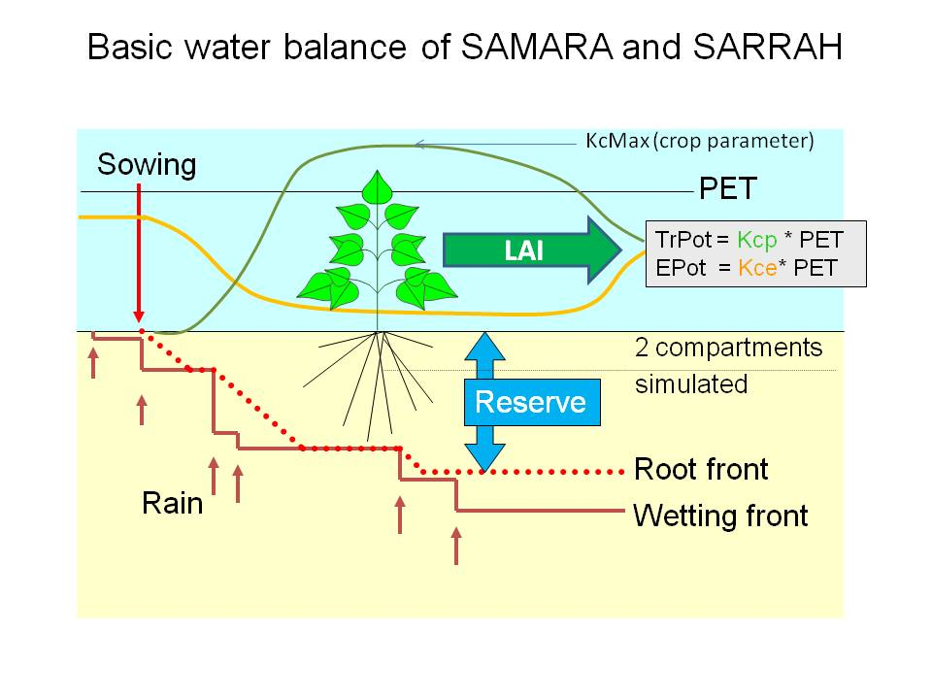

* + 1. *Soil and surface water reservoirs*

A surface soil reservoir (e.g. 100 mm) is used to calculate soil evaporation. It should not be too thick because drying of the surface layer creates a self-mulching effect that reduces evaporation, and this cannot be realistically simulated if this layer is very thick. A 2nd soil layer has variable depth because it ends at the root front, which progresses during crop development. Root front progression extends the 2nd layer according to development-phase dependent rates set by user, unless it is (1) stopped as it reaches the current wetting front (a phenomenon happening after a dry season as the rains fill up the soil gradually), or (2) when it reaches the limit of the user-defined soil depth (e.g., corresponding to a hard plow pan, or an iron-concretion “carapace” as in many red tropical soils).

Soil reservoirs fill up from top to bottom, with no capillary rise simulated. Soil shrinkage and swelling are also not considered. Deep drainage is limited by the soil parameter PercolationMax (mm/d). Each reservoir contains 4 functional water reservoirs:

* the non-evaporable part (water content of air-dry soil),
* the evaporable but non-transpirable part (fixed by the wilting point or HumPF),
* the transpirable part but non-drainable part located between wilting point and field capacity or HumFC (this important reservoir is called ResUtil=HumFC-HumPF; it is the source of transpiration in upland crops), and
* the drainable part in a saturated soil (located in macropores that normally are filled with air); this reservoir is available for transpiration unless the genotype is declared as highly susceptible to water logging (crop parameter WaterLoggingSens is set to 1)

An additional water reservoir is located outside the soil, generated by situations where water supply has filled up all soil reservoirs and the supply continues to exceed PercolationMax. Ponding only occurs if the parameter BundHeight is superior to 0, otherwise the water runs off. Filling-up of bunded plots can lead to spill-over runoff as well.

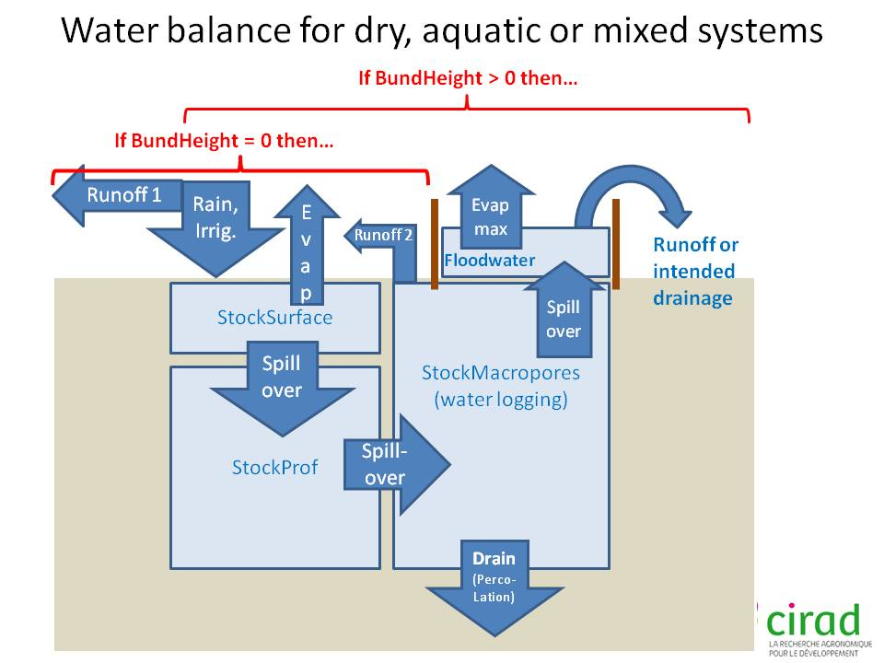

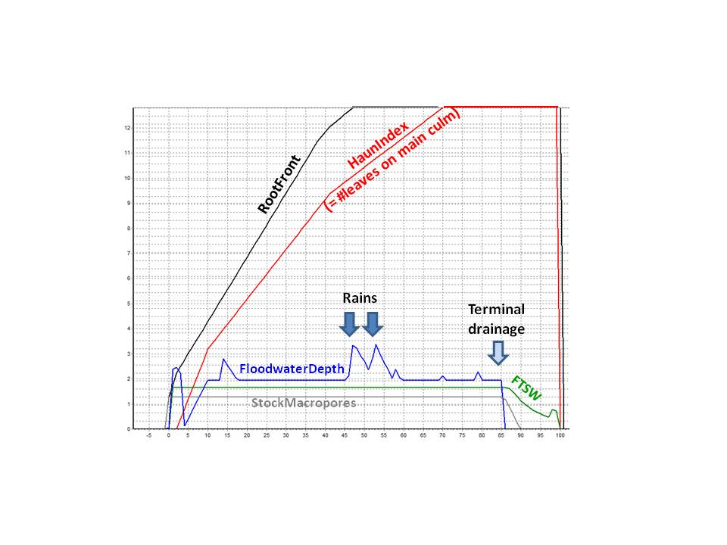

* + 1. *Driving force of evaporation and transpiration*

Potential evapotranspiration according to FAO (PET, or ETP in French; mm/d) is the environmental variable driving soil evaporation and plant transpiration. It is calculated by the model using standard synoptic weather station variables as inputs on a daily basis.

* + 1. *Partitioning of daily incoming water*

Rain or irrigation water is partitioned daily in the following way:

* Under non-bunded upland situations (BundHeight=0), primary runoff is simulated as a fraction (PercRuiss) of a rain (or irrigation) event exceeding a user defined critical value (SeuilRuiss). Secondary, additional runoff can add to this if the soil is saturated or bunds are over-flowing. Secondary runoff is simulated AFTER partitioning of the water supply. All runoff is collectively described fy the state variable Lr.
* Soil surface (or ponded-water surface) evaporation is calculated as a function of ETP, surface soil humidity and ground cover.
* The remaining water supply infiltrates the soil and adds to its water content. As in a given soil layer the soil water content exceeds field capacity (HumFC), the wetting front progresses within the user-set soil depth.
* If the entire soil column has attained HumFC, deep drainage (Dr) occurs in the form of percolation, within the limits of PercolationMax.
* If deep drainage attains its maximum, the excess water supply fills up the macropores (aur spaces) of the soil from bottom to up. Water logging begins that can be simulated as a stress.
* If all macropores are filled (the soil attains saturation = HumSat), excess water either runs off (secondary runoff in upland with BundHeight=0) or ponds (BundHeight>0).
* If ponded water depth exceeds BundHeight, excess water supply spills over as secondary runoff.
* The Fraction of Transpirable Soil Water (FTSW) is calculated as the soil water available for transpiration (in ResUtil plus macropore reservoirs), divided by ResUtil. FTSW can range between 0 (maximal drought) and 1 (field capacity) or even >1 (water logging).
* The crop extracts water from the root layer (first the surface reservoir, then the deeper reservoir) as a function of (1) ETP, (2) ground cover in terms of relative light interception, (3) genetic crop coefficient Kc (FAO) and FTSW using the FAO P-Factor algorithm.

With this, the water partitioning of the day is completed and the situation is set for the next day’s partitioning cycle.

* + 1. *Stress vs transpiration and assimilation*

SAMARA simulates a maximal transpiration rate (TrPot) as the product of ETP, canopy light interception ratio (LTR; as fraction) and Kc (FAO). TrPot is then multiplied with a stress coefficient (Cstr; state variable; range 0…1) to obtain actual transpiration (Tr). Note that TrPot can be reduced by **leaf rolling** as a function of FTSW, ETP and 2 crop parameters (RollingBase: maximal reduction in effective LA by rolling; and RollingSens for sensitivity of response).

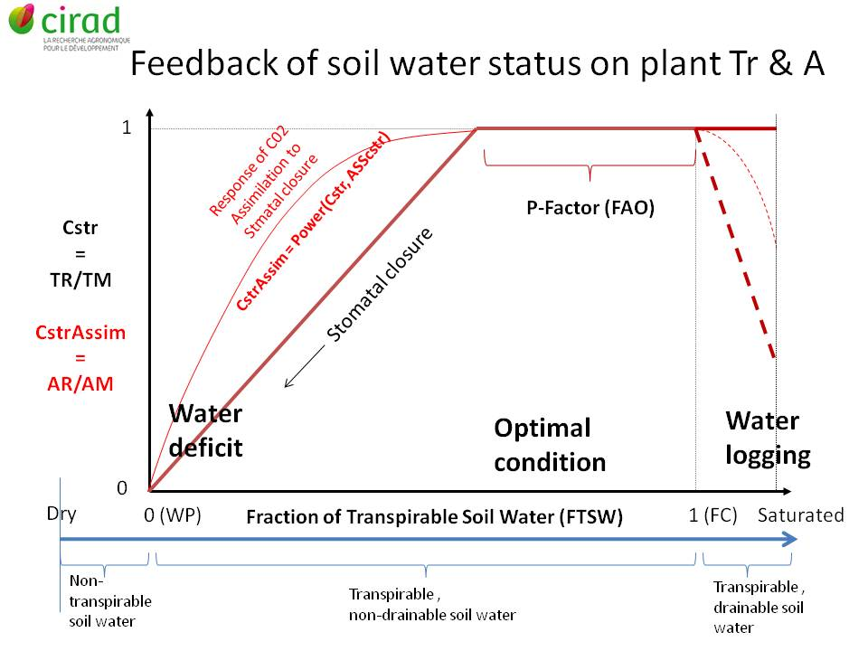

**Stress coefficient Cstr** can assume values between 0 (maximal stress) and 1 (no stress). It is generic as it is affected by different stresses that cause stomatal closure, such as drought, water logging or chilling. Cstr can optionally affect development rate (stress thus increasing duration) with the parameters DevCstr (0…1)

For the case of drought, the crop parameter PFactor sets the FTSW below which stomata start closing.

For the case of water logging, Cstr is propotional to the fraction of the root system that is water logged (macropores filled up), multiplied with (1-WaterLoggingSens).

Submergence starves the plant by suppressing photosynthesis totally.

In SAMARA V1 and SARRAH, Cstr affects transpiration and carbon assimilation identically and proportionally. In SAMARA V2, a crop parameter AssCstr (0…1) generates a curvi-linear response of Assim to Cstr (Assim = AssimPot * Cstr^AssCstr). With a value of 0.5 for AssCstr, assimilation rates thus become less sensitive to stomatal closure than transpiration rates, which roughly corresponds to physiological reality.

Thermal response of assimiliation rates is not considered stress related and do not involve Cstr. An algorithm was implemented on the basis of the cardinal temperatures for development, but allowing for a broader optimal thermal range as compared to the Topt1-Topt2 range.

* + 1. *Thermal and drought induced sterility*

SAMARA simulates a reduction of post-floral panicle sink potential proportional to stress-induced spikelet sterility (SterilityTot). SterilityTot is composed of SterilityCold, SterilityHeat and SterilityFtsw. The 3 components are not additive (because there cannot be SterilityTot>1). Instead, the partial spikelet fertilities (1-SterilityX) are multiplied with each other.

For each of the 3 vectors for sterility, 2 crop parameters set the level at which sterility begins and where it is maximal, assuming linear response between the two levels. For example, if SterilityCritCold1=18 C and SterilityCritCold2=14 C, no sterility will be observed above 18 C and total sterility below 14 C.

For cold effects, the daily minimum air temperature during microspore stage (booting) is considered as vector, for heat effects it is the daily mean temperature around flowering, and for drought effects it is the FTSW around flowering. Effects are simulated on a daily basis during the sensitive period (ca. 10 d) and then averaged.

* 1. ***Cultural practices***
     1. *Population density*

Field population density (hills /ha) is set by the parameter DensityField. The user can also set the number of plants per hill (parameter PlantsPerHill), which can further increase population if PlantsPerHill>1 . This does not have exactly the same effect because due to clumping, the canopy closes slightly later when several plants are concentrated in one hill.

The parameter DensityNursery sets the population of the seedbed nursery used for transplanting, on the same basis. Note that all simulated crop variables are on a per-hectare basis, so the high population in the nursery leads to a very rapid increase in biomass and LAI, which then drops to much smaller values as we move from the nursery to the field after transplanting

As opposed to other crop models, SAMARA simulations are very sensitive to population due to consideration of physiological competition effects. If conventional models are usually too insensitive to population (because mostly, population effects act only through initial conditions), SAMARA may be over-sensitive at times, resulting in much senescence, low reserve status and low panicle sink potential under high densities. However, SAMARA permits simulating crowding-sensitive and –tolerant cultivars on this basis, which most crop models cannot.

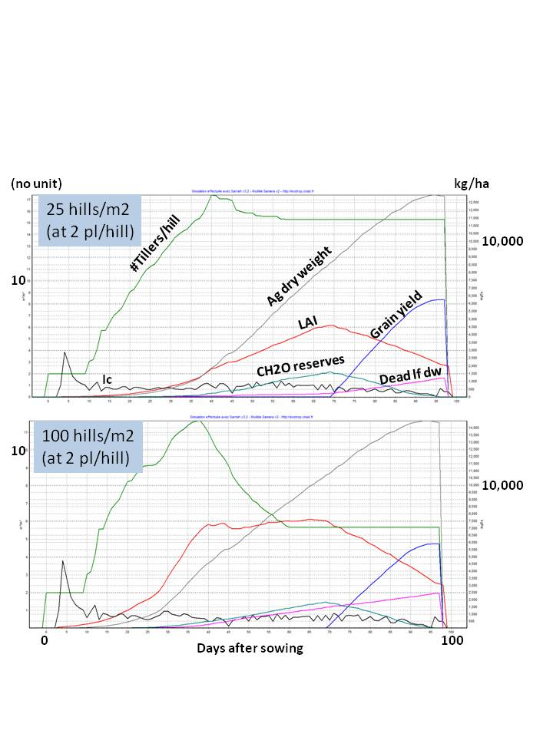

* + 1. *Transplanting*

Transplanting of seedlings is only authorized for BundHeight>0 (bunded fields that allow ponded water). Seedbed duration and population can be set by user, as well as the intensity of transplanting shock during the initial ca. 7 days after transplanting (CoeffTransplantingShock, 0…1). The latter affects both assimilation rates and development rate, thus increases seed-to-seed crop duration if CoeffTransplantingShock > 0. Transplanting shock is not a crop parameter but a cultural parameter because it depends on management (competition in seedbed, quality of seedling pulling, shading and watering during transport, etc.).

When transplanting, it depends on the farmer’s practice how deep the root system initially is (depth to which the roots were pushed into the soil). The cultural parameter TransplantingDepth sets the appropriate value in mm.

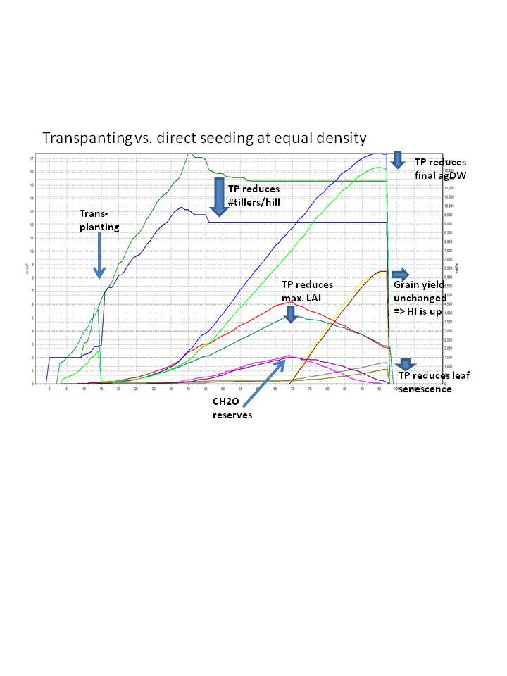

* + 1. *Irrigation and water management*

SAMARA V1 already permitted programming of individual irrigation events for upland crops. SAMARA V2 provides for an additional array of irrigation options for aquatic rice culture (for Bundheight>0).

If no irrigation is chosen (Irrigation=0), the bunded plots may have variable conditions between flooding and dryland. In general, this choice increases yield significantly because runoff is reduced and more water is stored on the plot, unless PercolationMax is so high that the benefit is not realized (e.g., very sandy soil or very little rain). SAMARA V2 simulates this very well.

A special feature provides for automatic life-saving drainage in bunded plots, in order to prevent submergence (important particularly for young seedlings or very high bunds). In this mode, it is assumed that the farmer implements surface drainage to the extent that submergence of more than 50% of the plant (in terms of canopy height) is avoided.

If IrrigAuto is set to 1, automatic irrigation is implemented daily to ensure that plots are filled up to X% of BundHeight every morning (parameter IrriAutoTarget, indicates fraction of BundHeight, e.g., 0.5). This should usually be combined with an activation of life-saving drainage because a farmer who cares to irrigate will not want to drown his seedlings. The IrrigAuto mode also provides for an initial irrigation flush prior to planting to saturate the soil. If the crop is transplanted, an initial irrigation flush is also applied prior to transplanting. In that case, the water used for the seedling nursery is not counted in the Total crop water balance (e.g., CumIrrig, CumWaterUsed, WUE, etc.), because the nursery occupied only very little space.

A new feature in SAMARA V2.1 is the cultural parameter FtswIrrig (0.2…2), which sets the FTSW (soil moisture) that must be attained before the next automatic irrigation is implemented. If the value is >>1 (e.g., 2), automatic irrigation will fill up the floodwater every day to the depth chosen by user (IrrigAutoTarget). If FtswIrrig=1, irrigation happens only once all the floodwater and drainable water in soil macropores has disappeared (wet but aerated soil), which can take days after the last irrigation. Lastly, if FtswIrrig<1, water deficit is allowed to develop before irrigation resumes. **This mechanism allows for easy implementation of AWD** (alternate wetting and drying).

Another new feature in SAMARA V2.1 is the **possibility to program a drought period** for an automatically irrigated crop. The period of non-irrigation is set by IrrigAutoStop and IrrigAutoResume (in days after sowing). Note that before a stress develops, the floodwater and water in macropores need some time to disappear by evaporation, transpiration and/or percolation.

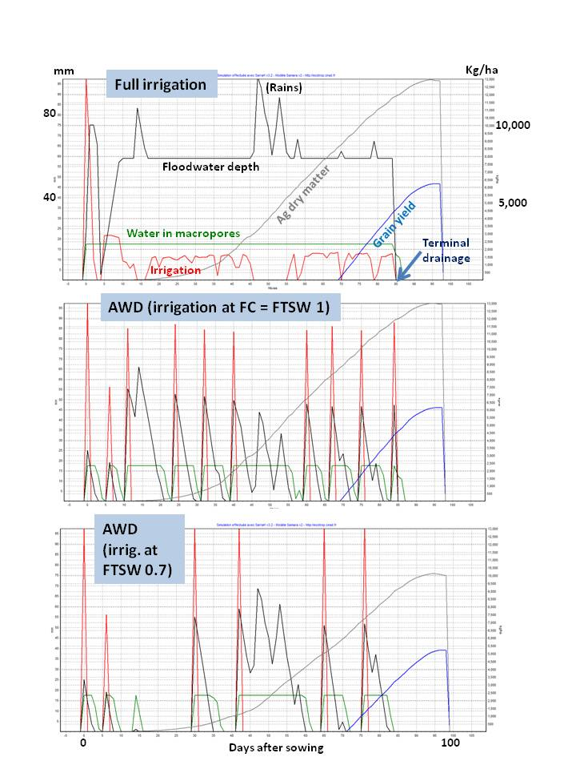

SAMARA V2.1 also provides for user choice of **terminal plot drainage** after flowering (parameter PlotDrainageDAF, in days after flowering). This can also save water but may have trade-offs with terminal drought.

SAMARA V2.1 permits evaluating all these water management practices on the basis of output water-balance variables. Cumulative amounts of rainfall, irrigation water supply, runoff, drainage, evaporation and transpiration can be simulated and output, as well as total water put in and total water consumed (the latter are not exactly identical because there may be variable storage in the system). Water use efficiency (WUE) is also output on a crop and field scale. Radiation use efficiency (RUE) and transpiration efficiency (TE) are also calculated.

**Literature cited**

Asch F., M. Dingkuhn, K. Dorffling, 2000. Salinity increases CO2 assimilation but reduces growth in field‑grown, irrigated rice. *Plant and Soil* **218**, 1-10.

Combres C*, Pallas B*, Rouan L, Bonnal V, Mialet-Serra I, Braconnier S, Soulié JC, Dingkuhn M. 2012.  Simulation of inflorescence dynamics in oil palm and estimation of environment-sensitive phenological phases. A model based analysis. *Functional Plant Biology* ***in press****.*

Dingkuhn, M**.**, Kouressy, M., Vaksmann, M., Clerget, B., Chantereau, J. 2008. Applying to sorghum photoperiodism the concept of threshold-lowering during prolonged appetence. *European Journal of Agronomy* **28**, 74-89.

Heinemann AB, Dingkuhn M, Luquet D, Combres J-C. 2008. Characterization of drought stress environments for upland rice and maize in central Brazil. *Euphytica* **162**, 395-410.

Ingram, K.T., M. Dingkuhn**,** R.P. Novero, E.W. Wijangco. 1990. Growth and CO2 assimilation of lowland rice in response to timing and method of N fertilization. *Plant and Soil* **132**, 113‑125.

Kouressy M, Dingkuhn M, Vaksmann M, Heinemann AB. 2008. Adaptation to diverse semi-arid environments of sorghum genotypes having different plant type and sensitivity to photoperiod. *Agricultural and Forest Meteorology* **148**, 357-371.

Luquet D, Dingkuhn M, Kim HK, Tambour L, Clément-Vidal A (2006) EcoMeristem, a Model of Morphogenesis and Competition among Sinks in Rice. 1. Concept, Validation and Sensitivity analysis. *Functional Plant Biology***33**, 309-323.

Luquet, D., Y.H. Song, S. Elbelt, D. This, A. Clément-Vidal, C. Périn, D. Fabre, M. Dingkuhn. 2007. Model-Assisted Physiological Analysis of Phyllo, a Rice Architectural Mutant. *Functional Plant Biology* **34**, 11-23.

Luquet, D., Soulié, J.C., Rebolledo, M.C., Rouan, L., Clément-Vidal, A., Dingkuhn, M. 2012. Developmental dynamics and early growth vigour in rice. 2. Modelling genetic diversity using ecomeristem. Journal of Agronomy and Crop Science, (14 p.) [2012/06/21]. <http://dx.doi.org/10.1111/j.1439-037X.2012.00527.x> (**in press**).





















